REGISTRATION FORM
Take note that all information in this application will be treated confidentially.

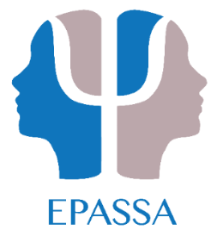 | Workshop on IEB concessions
IEB Concessions: A basic work shop on the process of assessment: IEB requirements, test battery, triangulation of data, report writing, case discussions

DATE: 26 November 2016
TIME: 09:00 to 14:00
VENUE: Epworth Children’s Village
47 9th Avenue
Extension 1
Lambton
Germiston
COST: R 550

CPD Points will be applied for.

Name:
Surname:
Mobile No.:
Office No.:
E-mail address:
HPCSA Registration No.:

Please send proof of payment and registration form to: gaydon@mweb.co.za

Banking Details: Educational Psychology Association of South Africa
Standard Bank – Sandton City
Branch Code 018105
Account # 027095045

Please indicate any dietary requirements: ____________________________

